**Vertical Order of a Binary Tree**

Problem

Given a binary tree, we need to print the vertical order of the binary tree.

Example

Given a binary tree in array representation



Its binary tree representation will be

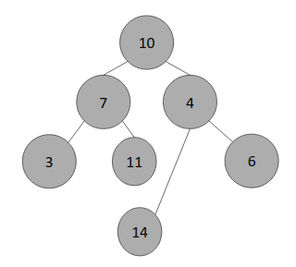

Computing horizontal distance approach

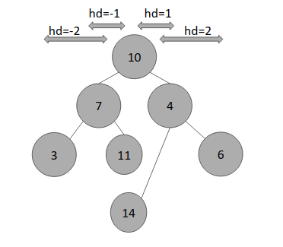

Vertical Order

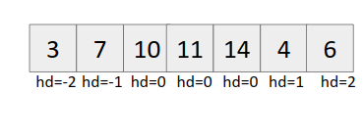

Approach (Using hashing)

1. Create a map (say hd) whose keys store the distance from the node and value stores a vector of nodes at the respective horizontal distance.
2. Start from the root node and recursively call left and right child with (hd-1) and (hd+1) as arguments.

Base Case:

*if(current_node == NULL)*

*return;*

1. Push the value into the vector corresponding to the horizontal distance (hd).
2. Output the map

Code

